­­



Submitted to

:

Sir. WAQAR AHMED

***BS-Software Engineering 4th-E***

Title: Assignment 2&3

SDA

Hamza Mehmood

Roll# SP-21-110

NUML-S21-23530



National University of Modern Languages

**What is LMS?**

A learning management system (LMS) is software or web-based technology that is used to design, implement, and evaluate a learning process. In its most basic form, it is used in eLearning and comprises of two elements: a server that performs the fundamental functions and a user interface that instructors, students, and administrators operate.

**QUESTION 1(a):**

**Draw a Class Diagram for LMS SYSTEM.**

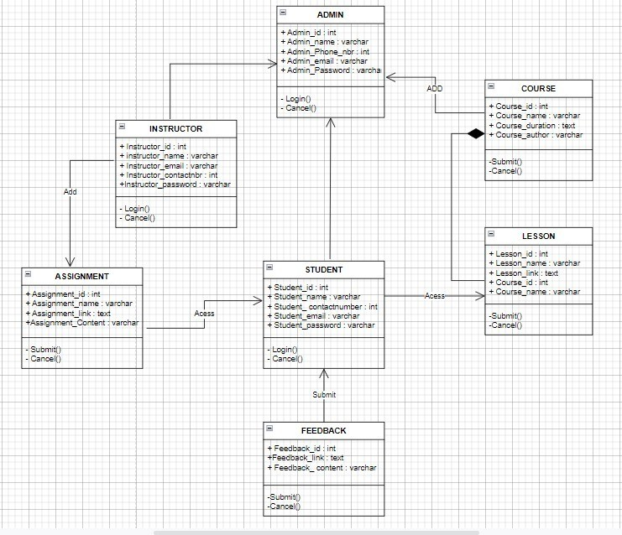

**QUESTION 1(b):**

**Draw a Use Case Diagram for LMS SYSTEM.**

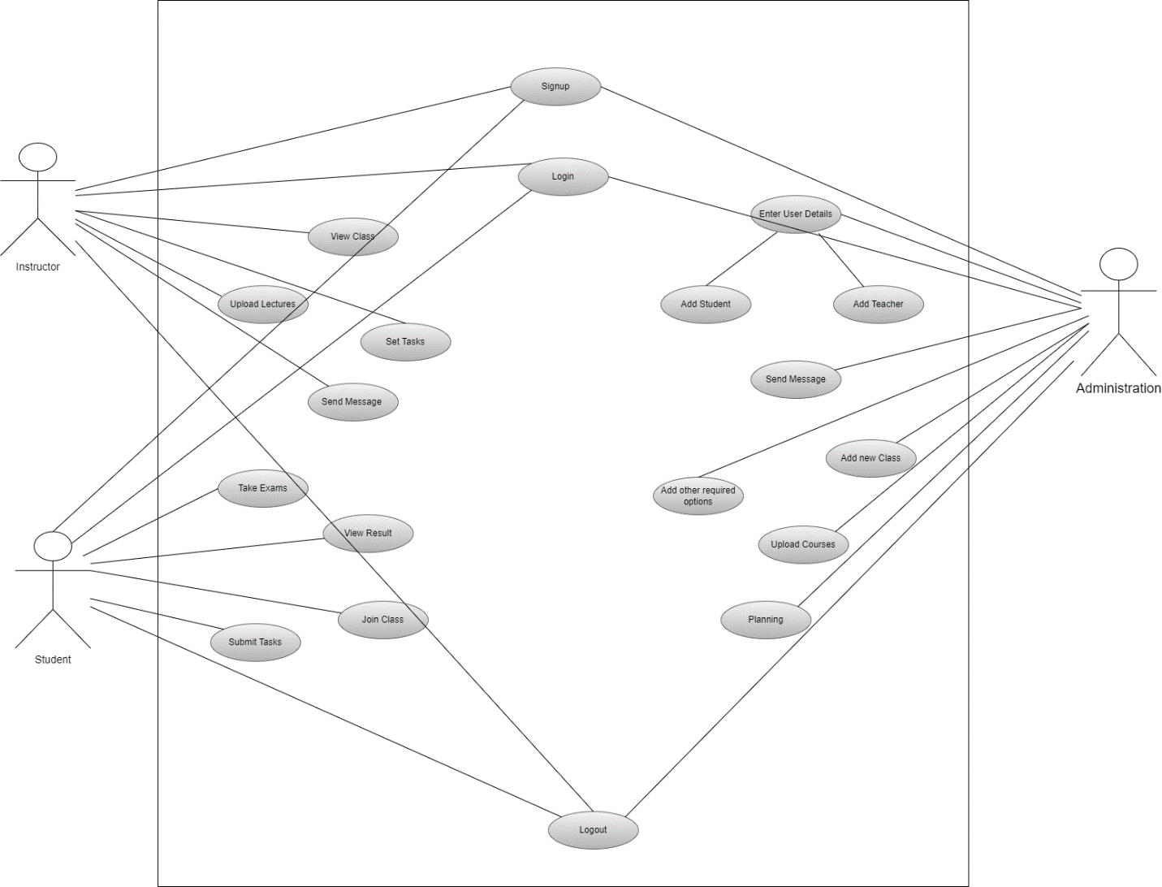

**QUESTION 2(a):**

**Draw a sequence Diagram of Major Components for LMS SYSTEM.**

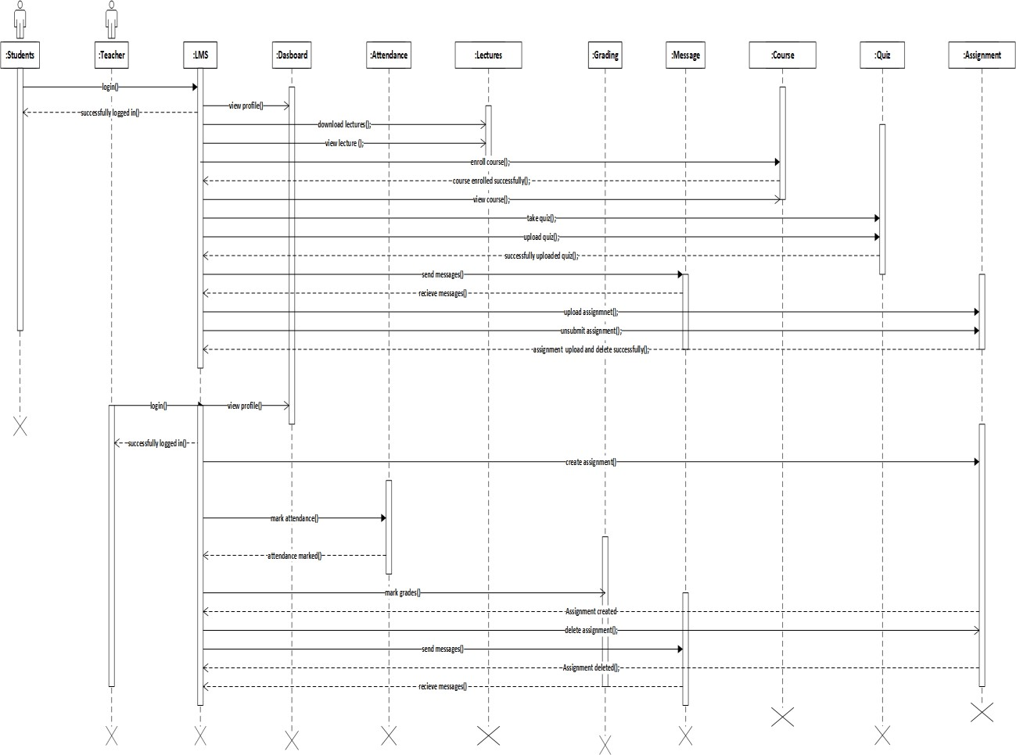

**QUESTION 2(b):**

**Draw an Activity Diagram for LMS SYSTEM.**

